TRURO CHRISTMAS PRIME STOCK & PRODUCE SOCIETY
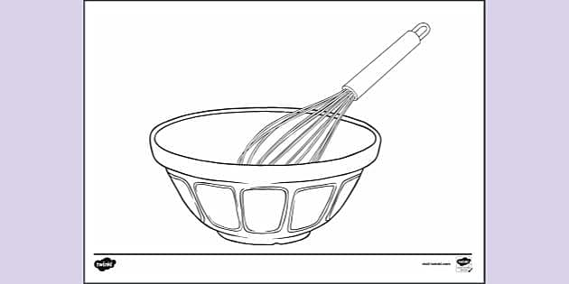
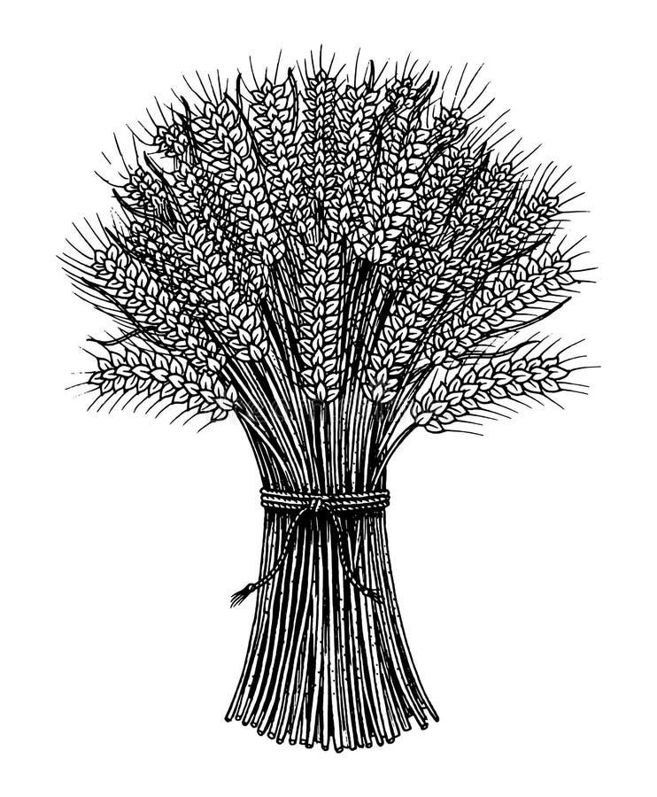
@ The Marquee, Truro Livestock Market, Truro
Wednesday 2nd December 2026

Farm Produce, Commercial Veg and Domestic Entry Form ***FREE ENTRY***

Class No. | Description of Exhibit  (Including size if requested) | No. of entries | For Sale/Donation (please tick) | Office Use
Entries Close on Wednesday 4th November 2026
As Marquee Space is Limited No Late Entries will be Accepted.

All entry forms must be received by 4th November, no telephone entries will be permitted.

This form is to be sent to:
Email: tpentries@gmail.com
Or
Mrs E. Harris, Acland Farm, Blackwater, Truro, TR4 8HP

I HEREBY CERTIFY that the above particulars are, to the best of my knowledge, true & correct
I have read the rules as published in the Society’s schedule.

Name & Address (please print): ………………………………………………………………………………………………...……………
…………………………………………………….......Telephone……………………………………Mobile.....................……….……..
Email: …………………………………………………………………………………….

Signed .........................................................................

Name of WI or YFC ……………………………………………………….……………………….................................................

If you do not wish to be included on our mailing list please tick here.

